Name: __________________________________

**Life Science: Diversity of Life**

Review

1. **What are the SEVEN characteristics of LIVING THINGS????**
   1. All living things are composed of __________________
   2. All living things ______________________
   3. All living things use ___________________________
   4. All living things need to get rid of waste (called ______________________)
   5. All living things respond to _____________________
   6. All living things ___________________
   7. All living things continue their species by ____________________
2. Discuss the “diversity” of living things in your backyard:

_________________________________________________________________________________________________________________________________________________________________________________________________________________________________________________________________________________________________________________

**3. What is Scientific Classification? (Bonus if you know the scientific name for classification!)**

_________________________________________________________________________________________________________________________________________________________________________________________________________

1. Why do scientists classify organisms? _______________________________________________________________________________________________________________________________________________________________________________________

**5. List the 5 Kingdoms: we focused on Kingdom Animalia!**

|  |  |
| --- | --- |
|  | KING |
|  | PHILIP |
|  | CAME |
|  | OVER |
|  | FOR |
|  | GOOD |
|  | SOUP |

1) ________________________________ 2)________________________________

3) ________________________________

4) ________________________________

5) ________________________________

6. **Fill in the Blanks: (on the table)**

**7. List the FIVE classes in the Animal Kingdom:**

1) ________________________________ 2) _______________________

3) ________________________________ 4) _______________________

5) ________________________________

**8. Using this Venn Diagram, show the difference between Vertebrates and Invertebrates.**

**9. Name the two different types of trees and explain what each means:**  
_______________________: ________________________________________  
_______________________: ________________________________________

**10. Why do you think Biological Classification is based on an animal’s internal characteristics rather than just its physical characteristics?**

_________________________________________________________________________________________________________________________________________________________________________________________________________

**11. Which Animal Class am I in and what are my key characteristics, separating me from the other classes?. You will need to know the differences of the classes for the test.**





**12. Why is a dolphin a MAMMAL and not a fish?**

_________________________________________________________________________________________________________________________________________________________________________________________________________

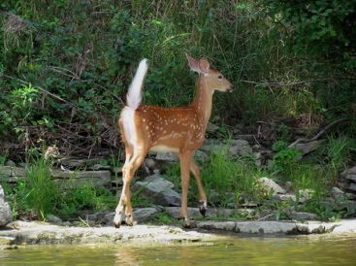

**13. List three Structures and three Behaviours that help a white tailed deer survive in Saskatchewan:**

|  |  |
| --- | --- |
| **Structures** | **Behaviours** |
|  |  |
|  |  |
|  |  |

**14. What is an adaptation? ______________________________________________________________________________________________________________________________________**

**15. List 4 types of adaptations:   
_________________________________________________________________  
_________________________________________________________________  
_________________________________________________________________  
_________________________________________________________________**

**16. Give an example of an animal that has adapted to living in a harsh environment and explain how it has done this.**

_______________________________________________________________________________________________________________________________________________________________________________________________________________________________________________________________________________________________________________________________________________

**17. _________________ are single-celled organisms that live in nearly every habitat on Earth!**

**18. Name two foods we eat which have bacterial cultures added to them: ______________ and ________________.**

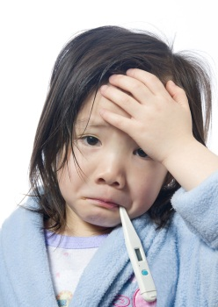

**19. Name one human disease caused by bacteria: _________________________**

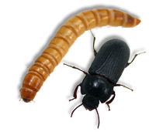

**20. Explain why our mealworms are classified as arthropods. Give 3 details about what makes arthropods different from other critters.**____________________________________________________________________________________________________________________________________________________________________________________________________________________________________________________________________________

**21. How are a snake and an earthworm similar? How are they different? Use some of the scientific words you’ve learned in this unit to explain your answer.   
_________________________________________________________________  
_________________________________________________________________  
_________________________________________________________________  
_________________________________________________________________**

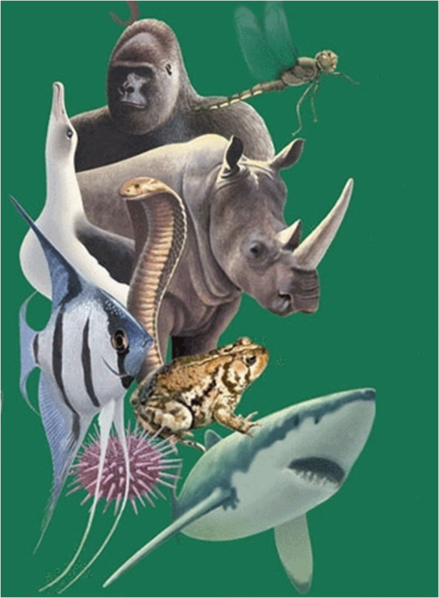

**22. What’s the main difference between warm – and cold-blooded animals? How does being warm-blooded or cold-blooded affect the lifestyle of the animal?  
____________________________________________  
____________________________________________  
____________________________________________  
____________________________________________  
____________________________________________  
____________________________________________  
____________________________________________  
____________________________________________**

**23. List 5 types of vertebrates  
_________________________________________________________________  
_________________________________________________________________**

**24. List 4 types of invertebrates  
_________________________________________________________________  
_________________________________________________________________**

**Name a group of living things that is difficult to see with just your eyes  
_________________________________________________________________  
_________________________________________________________________**

**25. Explain the difference between biotic and abiotic  
_________________________________________________________________  
_________________________________________________________________  
_________________________________________________________________  
_________________________________________________________________**

**26. Explain why it is important that Earth has so much diversity.  
_________________________________________________________________  
_________________________________________________________________  
_________________________________________________________________  
_________________________________________________________________**

