Covid-19: The Meme Challenge!

This week’s assignment is to create a meme that deals with some aspect
of Life in Quarantine, Remote Learning, the Corona Virus, and/or Covid-19,
using a piece of art from a world class museum as the picture image.
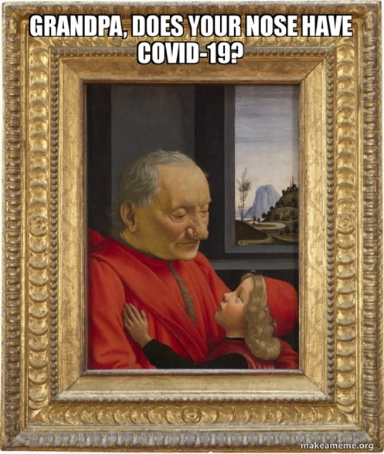
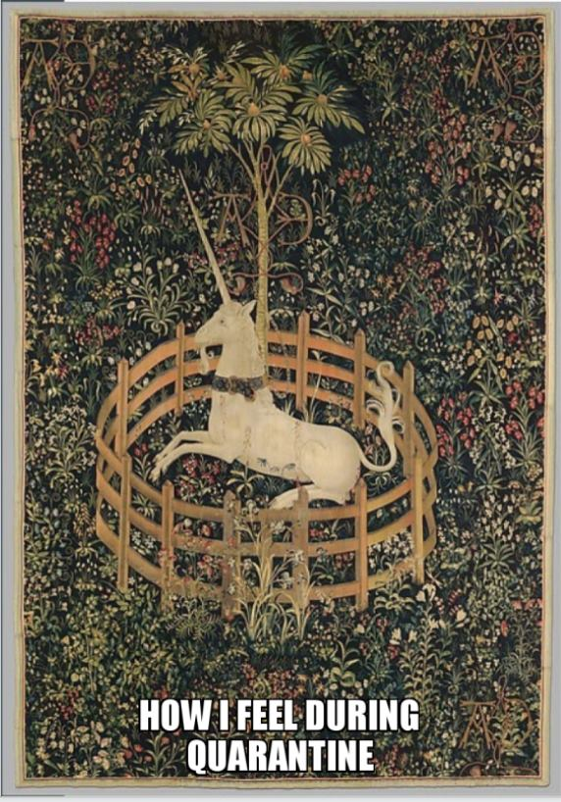
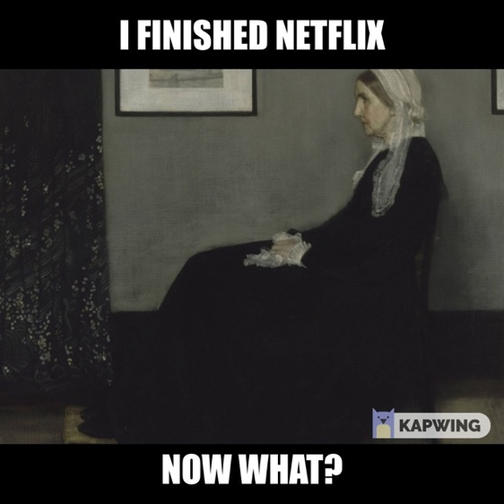
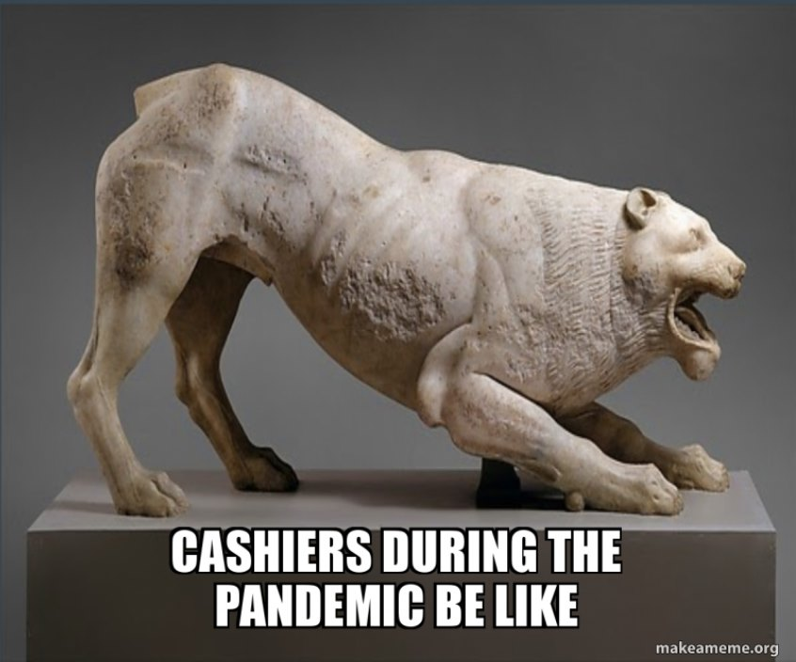

Covid-19 Meme Challenge

Memes have become part of our daily lives. What makes a great meme?
The best memes…
- are funny!
- reflect something that is timely in the news or pop culture.

Humor can help get us through difficult times. Look at all the funny memes that have been circulating the internet since the beginning of the Corona Pandemic!

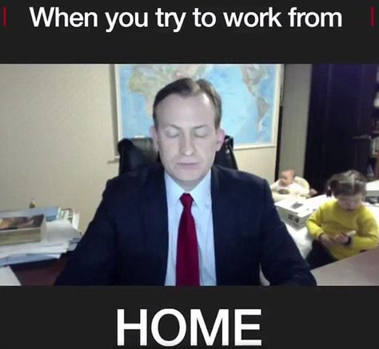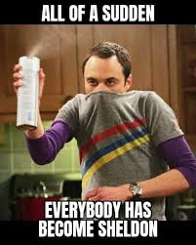
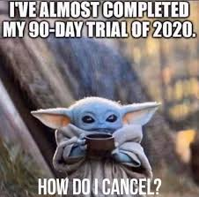
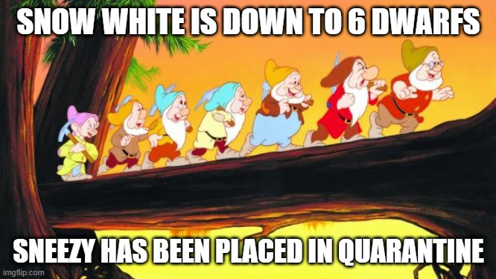

Keep going…

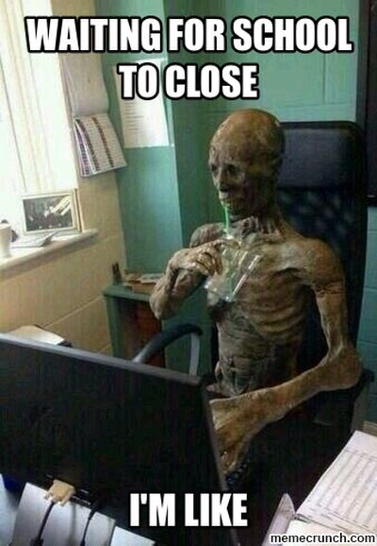

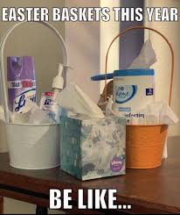

This week’s assignment is to create a meme that deals with some aspect
of Life in Quarantine, Remote Learning, the Corona Virus, and/or Covid-19,
using a piece of art from a world class museum as the picture image.

Overview of the assignment:
- Choose a piece of art from an online museum website and save it to your device.
- Upload the image into an online meme generator to add your text.
- Save your finished meme to your device and post it into our class bulletin board!
First, choose an image and record information about it

You might have a caption in mind and know the type of image that would fit the text, or you might be inspired by an image you find at random!

Choose from one of the links below to browse the collections of famous art museums. When you find an image you want to use for your meme, hover over the image and…
Right-click save as (title the image and designate location on your device to save it)

(If you are using a Chromebook without a mouse, a two-finger click = “right click”)

You must also write down
- The title of the art
- The artist’s name, (if known)
- The date created (if known)
- The museum that houses this work of art.

Massachusetts Museums Other Famous Museums

The Decordova Museum and Sculpture park in Lincoln The Metropolitan Museum of Art, New York
https://decordova.org/ https://www.metmuseum.org/toah/works/#!?time=all&geo=all&theme=all&dept=all

The Museum of Fine Arts in Boston The Louvre, Paris
https://www.mfa.org/ https://www.louvre.fr/en/selections

The Harvard Art Museums, Cambridge The Musee d’Orsay. Paris
https://www.harvardartmuseums.org/collections? https://m.musee-orsay.fr/en/works.html

The Isabella Stewart Gardner Museum in Boston
http://www.gardnermuseum.org/

The Peabody Essex Museum in Salem Note: Some art has nudity! Nudity in art is not uncommon, https://www.pem.org/ but please choose an image that is “school appropriate”.

Second, create your meme!

OPTION 1: (Quick and Easy, but not much choice.)
CLICK THIS LINK: https://makeameme.org/memegenerator

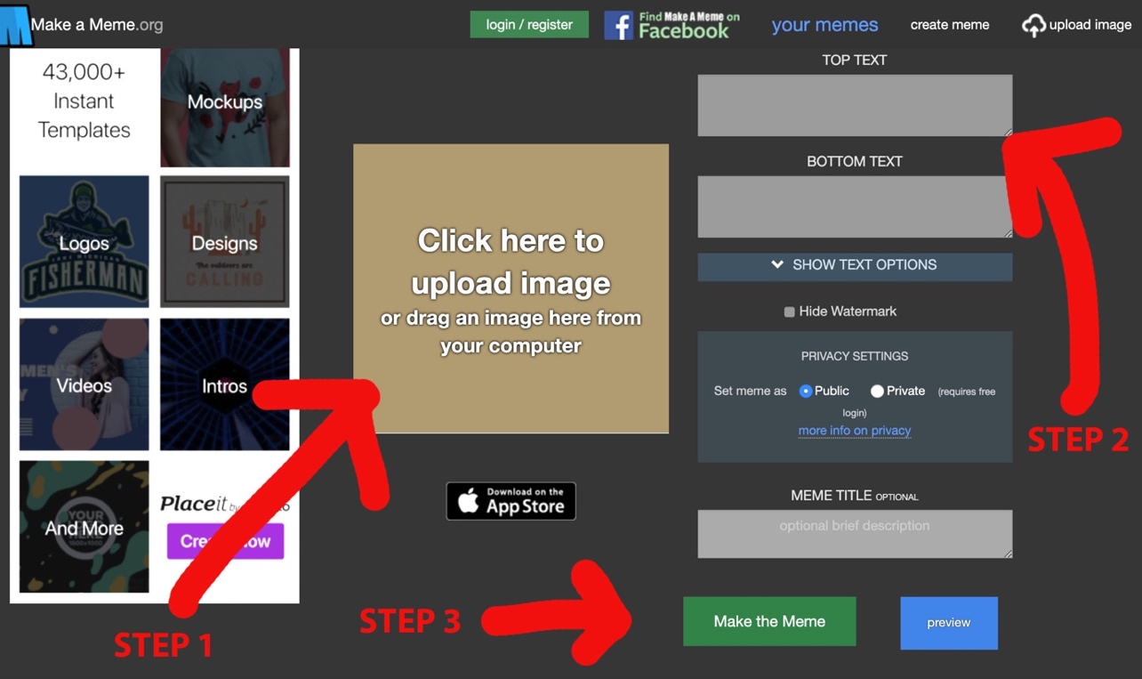

STEP 1: Upload the artwork you chose
STEP 2: Add text caption for the top and/or the bottom
STEP 3: Click “Make the Meme” to see your meme!

Instructions for https://makeameme.org/memegenerator continue on the next page…

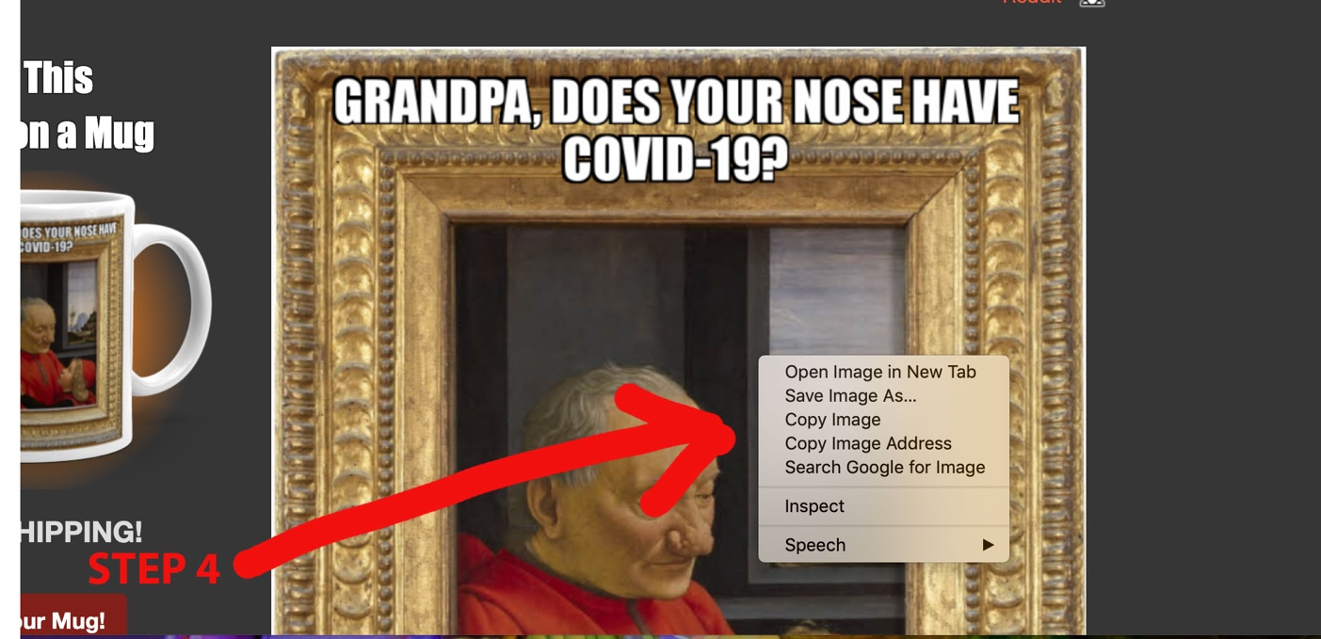

STEP 4: Right click on your completed meme “save image as” title it and select location on your device.

OPTION 2: (A bit harder, but more design options!)
CLICK THIS LINK: https://www.kapwing.com/meme-maker

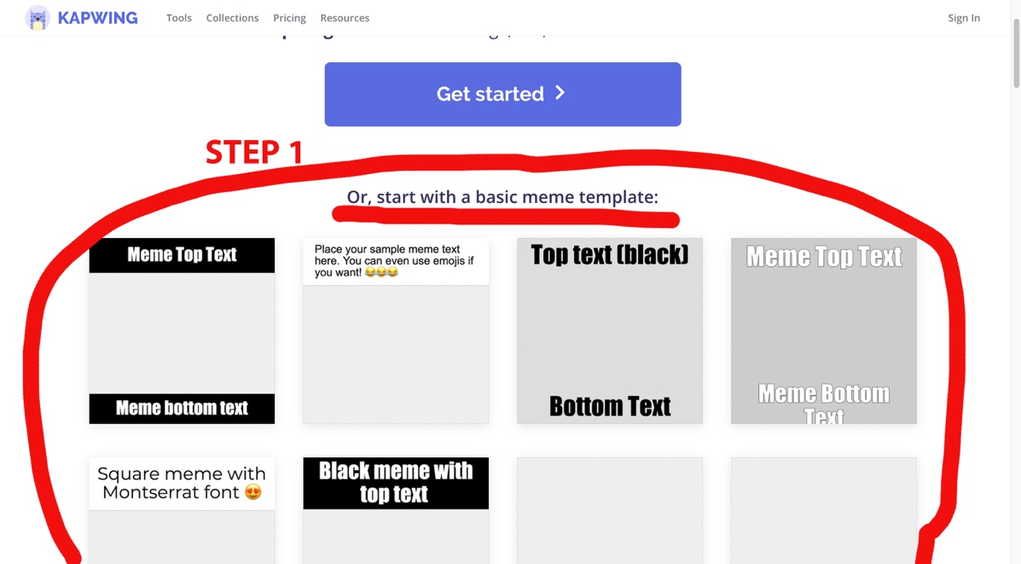

FIRST: Select one of the 8 basic meme templates by clicking on it.
A description of the template will pop up. Click “MAKE IT” to begin editing.

Instructions for https://www.kapwing.com/meme-maker continue on the next page…

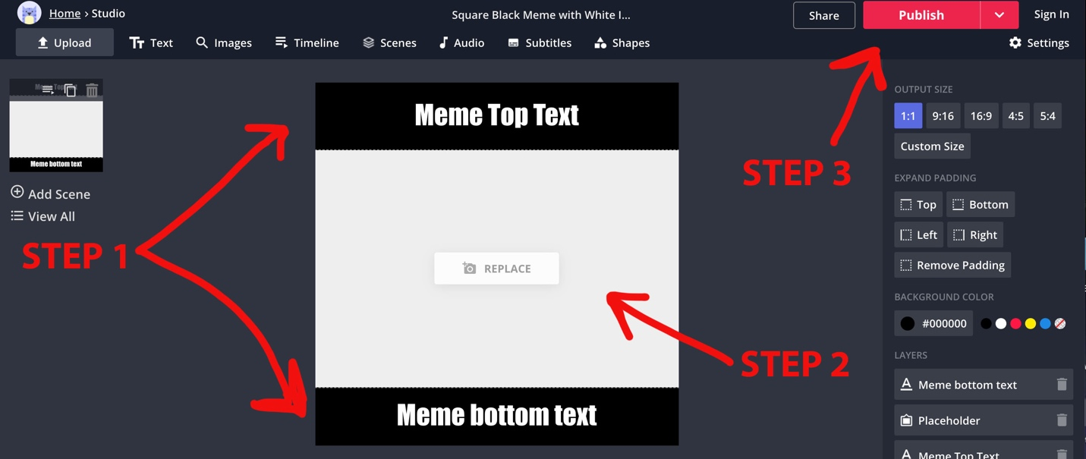

STEP 1: Edit text by clicking in the sample text boxes and replacing it with your caption.
STEP 2: Click on the center box to upload the artwork you chose.
STEP 3: Save your Meme by clicking the “Publish” button and selecting “Download”.
The meme will automatically save as the name of the template style you selected.

Two Examples…

This meme was made on This meme was made on

https://makeameme.org/memegenerator https://www.kapwing.com/meme-maker

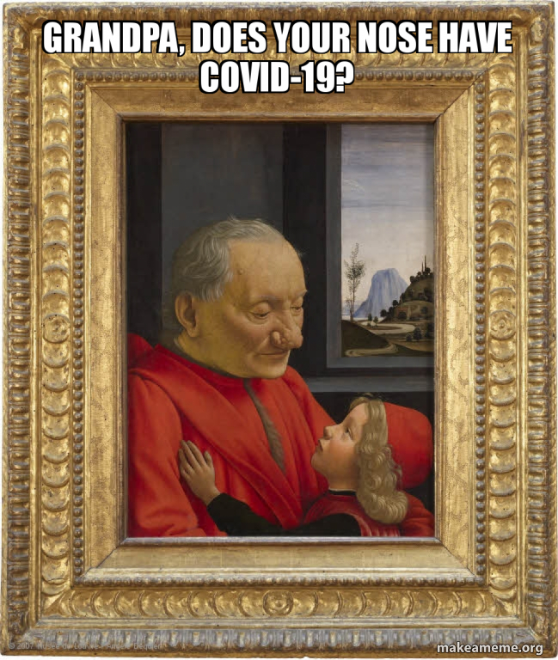

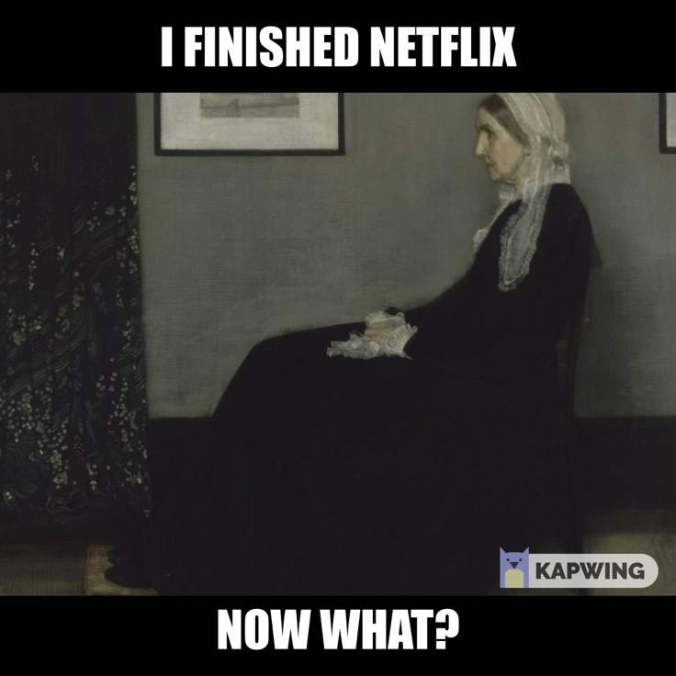

The Artwork: The Artwork:
“Old Man with a Young Boy” “Arrangement in Grey and Black, No. 1”
1490 1871
Domenico Ghirlandaio James Abbot McNeill Whistler
The Louvre Museum Musee d”Orsay

Be sure to submit your finished Meme on Google Classroom with the artwork’s
Title, Date, Artist, Museum

