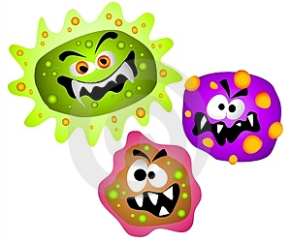
GERMS!

Germs are tiny organisms, or living things, that can cause _________________. Germs are so __________ that you need to use a microscope to see them. When they get in our bodies, we don't know what hit us until we have symptoms like a runny nose or ___________ throat, that say we've been attacked! Germs are so small that you can’t see them!
There are many types of ______________ (bacteria & viruses). Some we can get in our bodies by breathing __________ that has germs in it when somebody has coughed or sneezed. We can get other germs into our bodies by _________________ something that has germs on it and then putting our hands or food into our mouths without washing.
Washing hands is the best way to fight germs!!
YOU SHOULD WASH YOUR HANDS WHEN YOU:
Use the _____________.
Play with _____________.
Handle ___________.
_____________, sneeze or ___________ your nose.
Before preparing or touching __________.

INFECTIONS & IMMUNIZATION
When our bodies are under attack from germs, our body has a defence system: our __________________________. These tiny warriors fight against the invaders. Sometimes our immune system needs help recognizing the invaders, so we inject a very weak ____________ into our bodies (called an _________________________ or ____________________. ) Our bodies can then fight against the real disease.
Sometimes we get ________ or injuries, and then germs get into that opening. We should wash it out right away to clean the germs out so that we don’t get an ________________. OUCH!

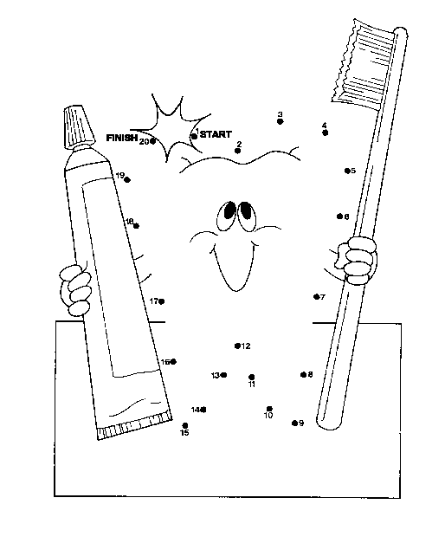
We also get germs on our ____________ from the food we eat. If there is sugar in the food, the “sugar bugs” or ___________ attacks our teeth and makes holes called c___________. We have to visit the dentist to get a ___________.

We can help our bodies to stay healthy by eating _________________________ and ________________. We know that there are four food groups:
dairy, protein, grains and fruits & vegetables.
We should eat some of each food group every day.

